%Date 10/26/2012
%Piter Garcia
%HomeWork Number 6

I = imread('2011_1HW5.tif');
figure, imagesc(I);
suptitle('BINARY IMAGE');

First, I uploaded the binary image to be processed.

SE1A = eye(5);
SE1B = imrotate(SE1A, 90);
SE2 = ones(3);
SE3 = ones(5);
SE4 = [1 1 1];
SE5 = [1 1 1]';

Second, I set up the structural elements that are to be used in both the erosion and dilation process.

figure,
Ise1AERODE = imerode(I,SE1A);
subplot(1,2,1),imagesc(Ise1AERODE);title('Structure Element 1A (SE1A)');

%figure,
Ise1BERODE = imerode(I,SE1B);
subplot(1,2,2),imagesc(Ise1BERODE);title('Structure Element 1B (SE1B)');
suptitle('EROSION 1 - Structure Element Figures');

figure,
Ise2ERODE = imerode(I,SE2);
subplot(1,2,1),imagesc(Ise2ERODE);title('Structure Element 2 (SE2)');

%figure,
Ise3ERODE= imerode(I,SE3);
subplot(1,2,2),imagesc(Ise3ERODE);title('Structure Element 3 (SE3)');
suptitle('EROSION 2 - Structure Element Figures');
%dislate

Third, I implemented the erode function from Matlab with the given structural elements described above following Matlab instructions. Then, I proceeded to output the result image with the right subtitle as requested.

figure,
Ise1ADILATE = imdilate(I,SE1A);
subplot(1,2,1),imagesc(Ise1ADILATE);title('Structure Element 1A SE1A');

Ise1BDILATE = imdilate(I,SE1B);
subplot(1,2,2),imagesc(Ise1BDILATE);title('Structure Element 1B SE1B');
suptitle('DILATION 1 - Structure Element Figures');

figure,
Ise2DILATE = imdilate(I,SE2);
subplot(1,2,1),imagesc(Ise2DILATE);title('Structure Element 2 (SE2)');

Ise3DILATE= imdilate(I,SE3);
subplot(1,2,2),imagesc(Ise3DILATE);title('Structure Element 3 (SE3)');
suptitle('DILATION 2 - Structure Element Figures');

Five, I proceeded to implement the same structural elements to the given binary image but with a different Matlab function called imdilate. This function was applied following instruction from Matlab, and details about its functionalities are given in the write up section of this assignment.

%carefully analyze
figure,
D32 = Ise3ERODE-Ise2ERODE;
subplot(1,3,1),imagesc(Ise3ERODE);title('Structure Element 3 (SE3)');
subplot(1,3,2),imagesc(Ise2ERODE);title('Structure Element 2 (SE2)');
subplot(1,3,3),imagesc(D32);title('SE3 - SE2 (D32)');
suptitle('(D32) ANALYSIS');

Sixth, subtracted from the image SE3 (5X5) the resulting image from SE2 (3X3).
The analysis of these results is given in the write up part of this assignment.

%OPEN
figure,
Ise1AOPEN = imopen(I,SE1A);
subplot(1,2,1),imagesc(Ise1AOPEN);title('Structure Element 1A (SE1A)');

%figure,
Ise1BOPEN = imopen(I,SE1B);
subplot(1,2,2),imagesc(Ise1BOPEN);title('Structure Element 1B (SE1B)');
suptitle('OPEN 1 - Structure Element Figures');

figure,
Ise2OPEN = imopen(I,SE2);
subplot(1,2,1),imagesc(Ise2OPEN);title('Structure Element 2 (SE2)');

%figure,
Ise3OPEN= imopen(I,SE3);
subplot(1,2,2),imagesc(Ise3OPEN);title('Structure Element 3 (SE3)');
suptitle('OPEN 2 - Structure Element Figures');

Seventh, I am applying the same structural elements set previously but with both erosion and dilate process combined, better known as open image processing. Details of this section are given below in the write up section of this assignment.

%CLOSE
figure,
Ise1ACLOSE = imclose(I,SE1A);
subplot(1,2,1),imagesc(Ise1ACLOSE);title('Structure Element 1A (SE1A)');

%figure,
Ise1BCLOSE = imclose(I,SE1B);
subplot(1,2,2),imagesc(Ise1BCLOSE);title('Structure Element 1B (SE1B)');
suptitle('CLOSE 1 - Structure Element Figures');

figure,
Ise2CLOSE = imclose(I,SE2);
subplot(1,2,1),imagesc(Ise2CLOSE);title('Structure Element 2 (SE2)');

%figure,
Ise3CLOSE= imclose(I,SE3);
subplot(1,2,2),imagesc(Ise3CLOSE);title('Structure Element 3 (SE3)');
suptitle('CLOSE 2 - Structure Element Figures');

Eighth, I am applying the same structural elements set previously but with both dilate and erosion processes combined, better known as close image processing. Details of this section are given below in the write up section of this assignment.

Write Up
Functions:
SE1A = eye (5);
SE1B = imrotate(SE1A, 90);
SE2 = ones(3);
SE3 = ones(5);
SE4 = [1 1 1];
SE5 = [1 1 1]';

1 - Function Descriptions:
SE1A: Returns the 5-by-5 identity 5 with 1's on the diagonal and 0's elsewhere.

SE1B: This rotates image by 90 degrees in a counterclockwise direction around its center point. imrotate makes the output image large enough to contain the entire rotated input image. This uses nearest neighbor interpolation for a structure element, setting the values of pixels in the image that are outside the rotated image to 0 (zero).

SE2: Creates a 3-by-3 matrix of ones that is going to be used as a structure element.

As an example of binary erosion, suppose that the structuring element is a 3×3 square, with the origin at its center, foreground pixels are represented by 1's and background pixels by 0's. For a 3×3 structuring element, the effect of this operation is to remove any foreground pixel that is not completely surrounded by other white pixels, assuming. These pixels must lie at the edges of white regions, and so the practical upshot is that foreground regions shrink, and holes inside a region grow.

SE3: Creates a 5-by-5 matrix of ones that is going to be used as a structure element. More details are explained above.
SE4: This is a row that acts as vector composed of three columns whose value is one. This vector is to be used as a structure element.
SE5: This is a row that acts as vector composed of three columns whose value is one. This vector is to be used as a structure element.


2. Is the white or black area ‘active’?
The white area is considered to be the area with “active” pixels because the values of these are not zero, while the value for the pixels in the black area is zero.
3. Is binary morphological processing a linear or non-linear operation?
Morphological processing is a non-linear operation.
Why?
Because morphological operations rely only on the relative ordering of pixel values, not on their numerical values, reason why they are also especially suited to the processing of binary images.
4. What morphological process adds pixels to the boundary of an object?
Erosion image processing.
5. What morphological process removes pixels from the boundary of an object?
Dilation image processing.
6. Define the OPENING process in morphological terms?
This performs morphological opening on the grayscale or binary image with the structuring element SE. SE must be a single structuring element object, as opposed to an array of objects. Also opening process can be used to perform opening with the structuring element trel(nhood), where nhood is an array of 0s and 1s that specifies the structuring element neighborhood. In fact, the morphological open operation is an erosion followed by a dilation, using the same structuring element for both operations.

7. Define the CLOSING process in morphological terms?
This performs morphological closing on the grayscale or binary given image with the structuring element SE. SE must be a single structuring element object, as opposed to an array of objects. Also, closing process can be used to perform closing with the structuring element strel(nhood), where nhood is an array of 0s and 1s that specifies the structuring element neighborhood. The morphological close operation is a dilation followed by erosion, using the same structuring element for both operations.

8. In your write-up analyze the resulting eroded images - compare the results and the structuring element used to obtain the result:

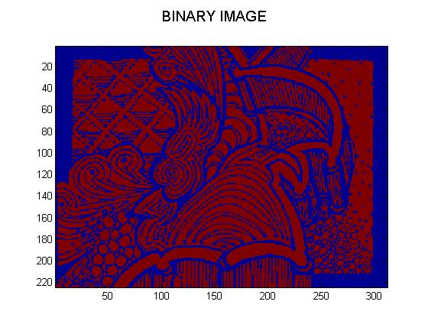
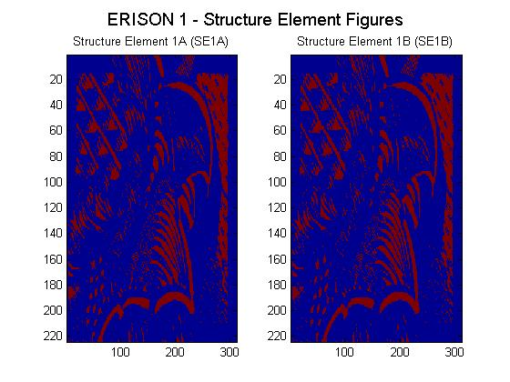
Image Analysis:
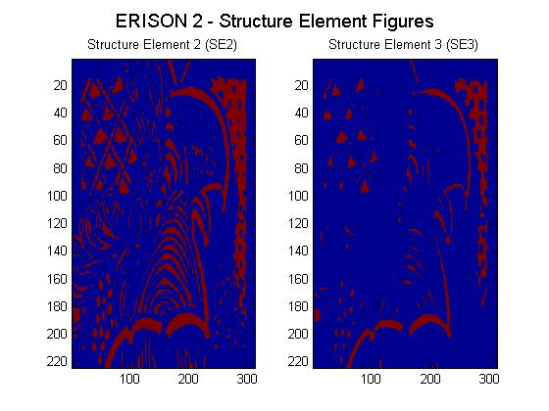
In the first two images we can observe that they are exactly the same result. This is because the eye(5) structure element is actually rotating the image 90 degree, through the 5 diagonals 1’s, as well as SE1B.
On the other hand, the 3×3 square is one of structuring element used for erosion operations in this assignment. Also, a larger structuring element such as 5X5 is being used to produce a more extreme erosion effect.
We can observe the following:
First structuring element 3X3 shows that the image in the middle increases in size as the border shrinks. We can note that the shape of the region has not been quite well preserved due to the shape of the structuring element.
Second, erosion using the given shaped structuring element does not round concave boundaries or preserve the shape of convex boundaries.

SE1A = Creates a structuring element. This creates a diagonal structuring element object.
Flat strel object containing 5 neighbors.
Neighborhood:
1 0 0 0 0
0 1 0 0 0
0 0 1 0 0
0 0 0 1 0
0 0 0 0 1
The diagonal streaks on the right side of the output image; this is due to the shape of the structuring element.
Comparison with SE1B: SE1A and SE1B are equivalent since eye (5) has 5 one’s in diagonal that rotate the image 90 degrees giving the same result as in SE1B, where SE1B as well as SE1A are using nearest neighbor interpolation for a structure element, setting the values of pixels in the image that are outside the rotated image to 0 (zero).

SE2 =
Flat strel object containing 3 neighbors.
Neighborhood:

1 1 1
1 1 1
1 1 1
Comparison with SE3 = the structuring element may have to be supplied as a small binary image, or in a special matrix format, or it may simply be hardwired into the implementation, and not require specifying at all. Where SE3 gives the shrinking effect described and since 5x5 is a larger structuring element this produces a more extreme erosion effect.


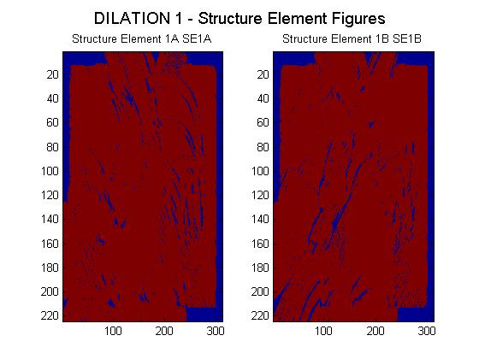
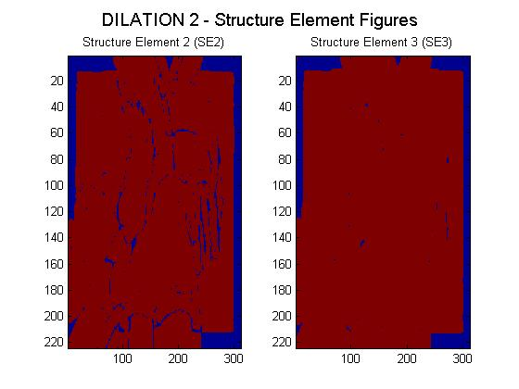
10. Analyze the resulting dilated images - compare the results and the structuring element used to obtain the result

As we can observe, the two first images are pretty similar. Nevertheless, some changes are noticeable due to the fact that they are both rotating opposite angles of the image. Dilating at 90 degrees is different than a filter of five diagonals one’s because of the change in pixels. Also, these images were produced by a dilation process using the SE1A and SE1B structuring elements. We can note that when dilating the original image the convex boundaries were rounded while the concave boundaries were preserved as they are.
The dilation process was made directional by using a less symmetrical structuring element such as SE1B structuring element that is 5 pixels wide and 5 pixels high. This dilated the image in a horizontal and vertical direction as well. Similarly, a 3×3 square structuring element with the origin in the middle of the top row rather than the center dilated the bottom of a region more strongly than the top.

SE1A = Creates a structuring element. This creates a diagonal structuring element object.
Flat strel object containing 5 neighbors.
Neighborhood:
1 0 0 0 0
0 1 0 0 0
0 0 1 0 0
0 0 0 1 0
0 0 0 0 1
The diagonal streaks on the right side of the output image; this is due to the shape of the structuring element.
Comparison with SE1B: SE1A and SE1B are almost equivalent, but eye (5) has 5 one’s in diagonal that convex boundaries and round them, and concave boundaries by preserving them as they are. On the other hand, SE1B uses nearest neighbor interpolation for a structure element. This sets the values of pixels in the image that are outside the rotated image to 0 (zero), reason why the image is not quite similar because in this case the dilation process is removing pixels not adding.

SE2 =
Flat strel object containing 3 neighbors.
Neighborhood:

1 1 1
1 1 1
1 1 1
Comparison with SE3 = dilates the image, pass the image bandwidth and the structuring element SE to the imdilate function. This adds a rank of 1's to all sides of the foreground object, whereas SE3 is larger structuring element and therefore has a more pronounced effect in the result of erosion. Dilations is also made directional by using less symmetrical structuring elements. A structuring element such as 5 pixels wide and 5 pixel high dilates in a horizontal and vertical direction as well. Similarly, a 3×3 square structuring element with the origin in the middle of the top row rather than the center dilates the bottom of a region more strongly than the top.

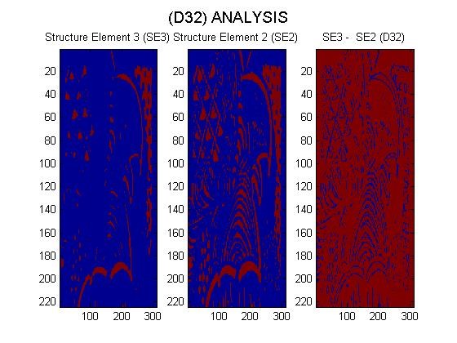
11. Carefully analyze the result, D32 and Display the resulting images with titles
From the image above we can come to the conclusion that the ERISON image processing has transformed in the following different aspects:

- The image has been shrunk by stripping away a layer of pixels from both the inner and outer boundaries of regions.

- The holes and gaps between different regions, in the original image, have become larger and small details have been eliminated.

A larger structuring element has a more pronounced effect in a binary image. However, the result of erosion with a large structuring element in this case is similar to the result obtained by iterated erosion using a smaller structuring element such as 2x2. Ifs₁ and s₂ is a pair of structuring elements identical in shape, with s₂ twice the size of s₁, then f s₂ ≈ (f s₁) s₁.

As a result, the Erosion image process is removing small-scale details from the given binary image and simultaneously reduced the size of regions of interest. By subtracting the eroded 2x2 from the original image, boundaries of each region can be found: b = f − (f s ) where f is the original image, and s is a 2×2 structuring element, and b is an image of the region boundaries.
Display the resulting images with titles
12. Carefully compare the results of opening and closing the original image
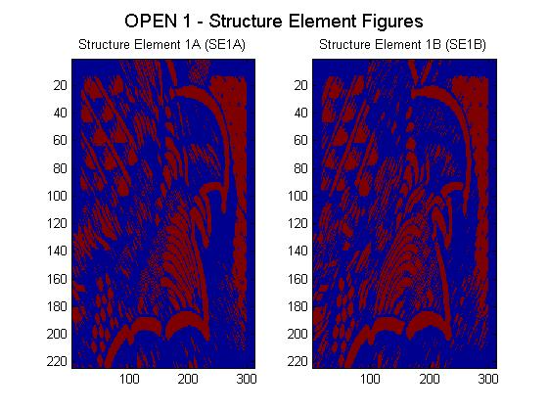
The effect of an opening on a binary image using a 3×3 square structuring element is illustrated below. The Opening in the figure is rather subtle since the structuring element is quite compact and so it fits into the foreground boundaries quite well. The erosions process performed followed by a dilation process increased the effect in the image, making the image is quite easily visualized.

The effect of opening in the given image can be explained as if each structuring element was taken and slide around inside each foreground region without changing its orientation. Unlike closing, all pixels covered by each structuring element, with the structuring element being entirely within the foreground region, are being preserved. However, all foreground pixels which cannot be reached by the structuring elements without parts of it moving out of the foreground region were eroded away. Once the opening was carried out, the new boundaries of foreground regions are all such that the structuring element fits inside them, and so further openings with the same element have no effect.

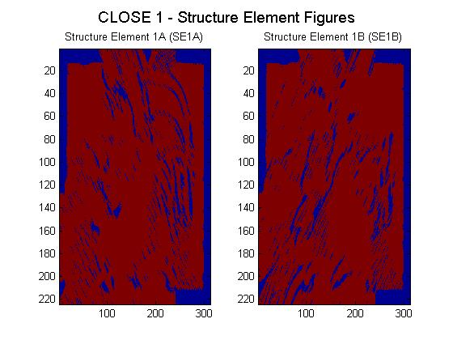
On the other hand, we are using a 3×3 square structuring element to achieve the effect of a closing. It was possible to perform it by performing first the dilation process followed by the erosion process. Closing selectively filled, in particular, background regions of an image. Unlike closing, which whether or not depends upon whether a suitable structuring element can be found, and that fits well inside regions that are to be preserved but that doesn't fit inside regions that are to be removed.

Display the resulting images with titles
12. Carefully compare the results of opening and closing the original image
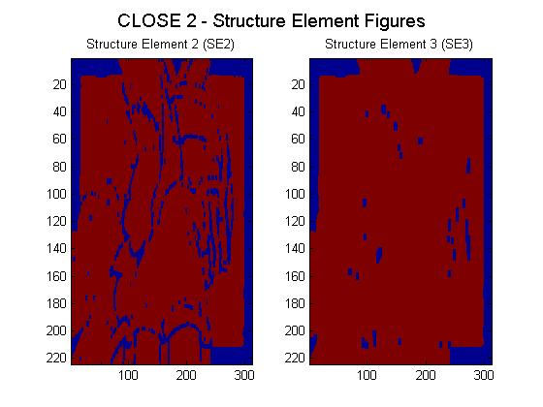
Performing an erosion on the image after the dilation, a closing, make the effect of closing quite easily visualized. This can be explained as taking the structuring element and sliding it around outside each foreground region, without changing its orientation. For any background boundary point, the structuring element was made to touch that point without any part of the element being inside a foreground region, making that point to remain background. Other pixels were set to foreground. Once the closing was carried out, the background region was such that the structuring element was made to cover any point in the background without any part of it covering a foreground point, and so further closings will have no effect.
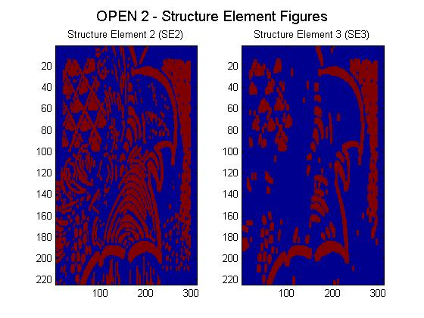
In fact, opening is defined as an erosion followed by a dilation and shows the opposite operation of closing, as we saw in the previous page, which is defined as a dilation followed by an erosion. As illustrated by these pictures, opening removes small islands and thin filaments of object pixels. Likewise, closing removes islands and thin filaments of background pixels. As a result, these techniques are useful for handling noisy images where some pixels have the wrong binary value. For instance, it might be known that an object cannot contain a hole, or that the object's border must be smooth.

Concluding Analysis

Erosion vs. Dilation
Figures above show how the image is changed by the two most common morphological operations, erosion and dilation. In erosion, every object pixel that is touching a background pixel is changed into a background pixel. In dilation, every background pixel that is touching an object pixel is changed into an object pixel. Erosion makes the image smaller, and can break a single object into multiple objects. Dilation makes the image larger, and can merge multiple objects into one. In fact Erosion is the dual of dilation, eroding foreground pixels is equivalent to dilating the background pixels.

Open vs. Close

The binary image was conducted by considering compound operations like opening and closing as filters. They may act as filters of shape. As we observed in the above pictures, opening with the given structuring element smoothed corners from the inside, and closing with the given structure element smoothed corners from the outside. Likely, both operations filtered out from the image any details that are smaller in size than the structuring element.

Personal Conclusion
As a result, best image result from my point of view was given by the opening image processing. The reason to this is because opening not only filtered the binary image at a scale defined by the size of the structuring element, but it also let those portions of the image that fit the structuring element be passed by the filter. The size of the structuring element is more important to eliminate noisy details but not to damage objects of interest. In this case, the structure element used for the opening process was enough to block the smaller structures and exclude them from the output image.

